EXPERIMENT-1

**NAME- RAJAT PANWAR**

**ROLL NO- R171218080**

**SAP ID – 500069414**

**SAM- 6TH**

**SUBJECT – APPLICATION CONTAINERIZATION**

**SUBMITTED TO-**

**MR. HITESH KUMAR SHARMA**

**1]. Download the provider and vagrant version 2.2.12**

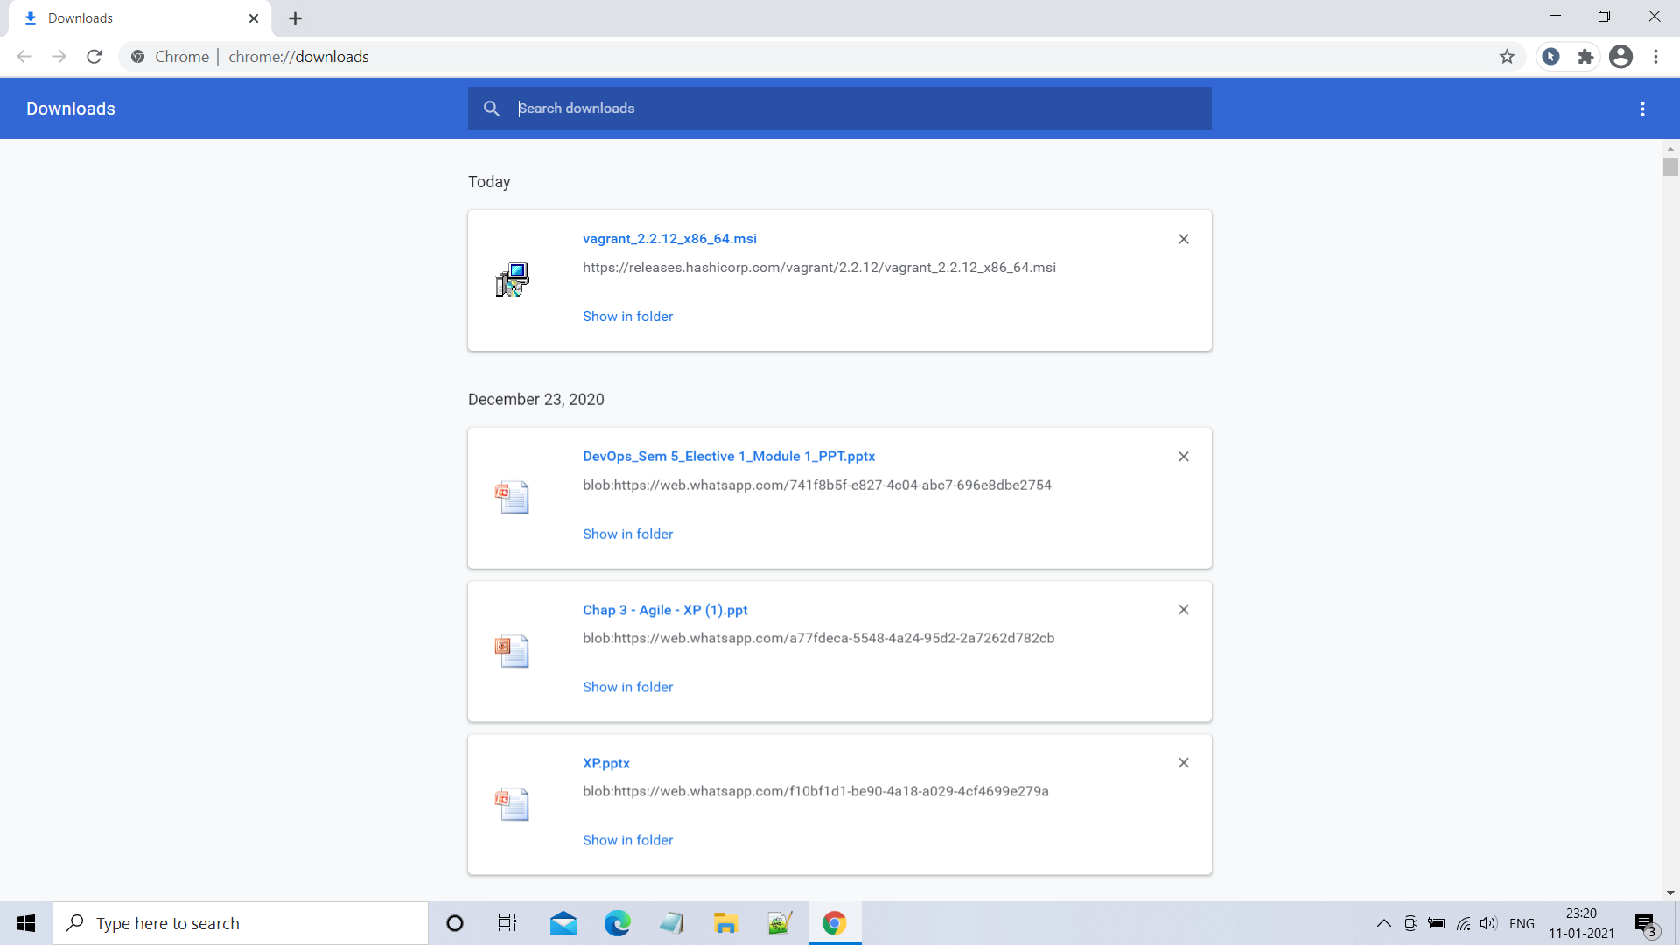

**2.] check vagrant version using “*vagrant --version*”**

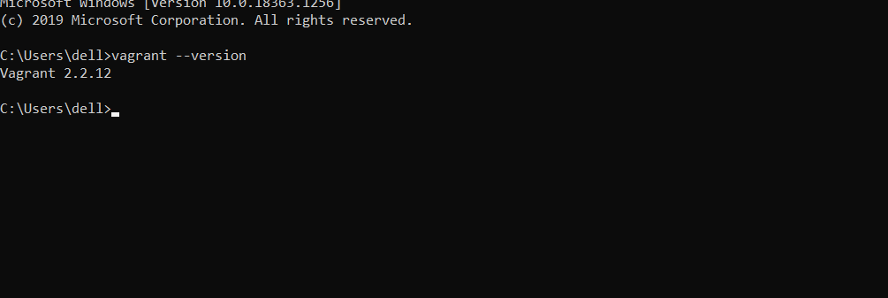

**3.] create a folder and use “*vagrant init”* command to initialize the vagrant file**

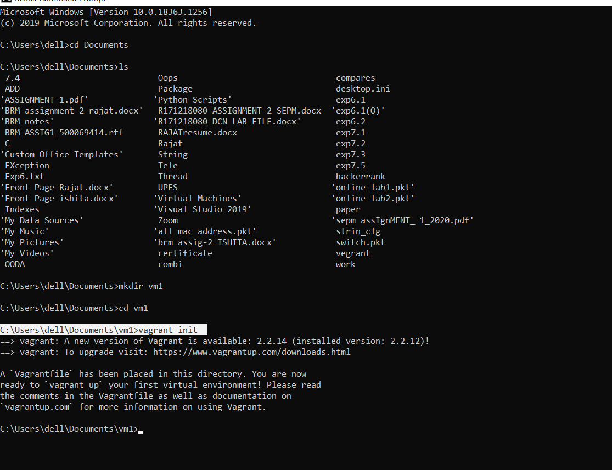

**VAGRANT FILE:-**

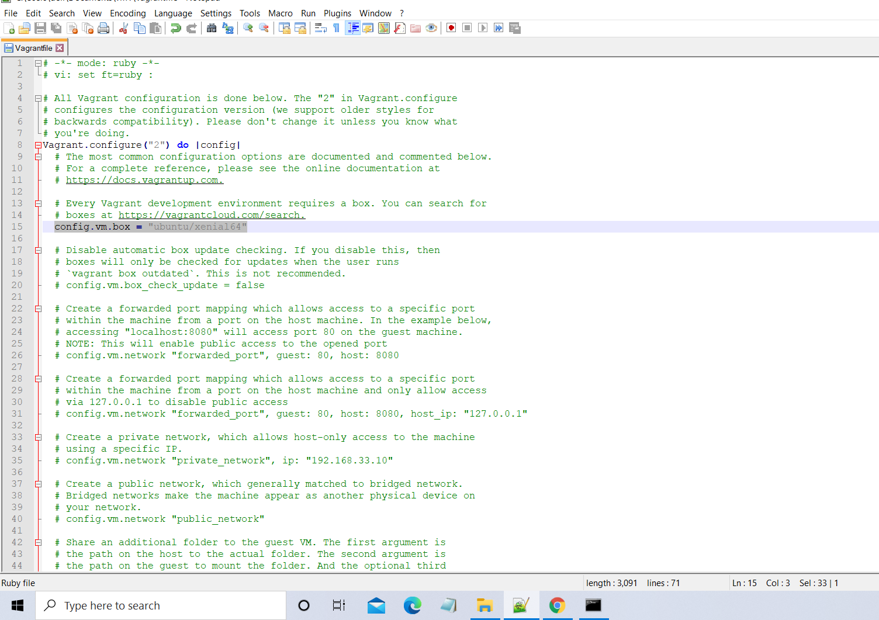

**4.] use *“vagrant up”* command**

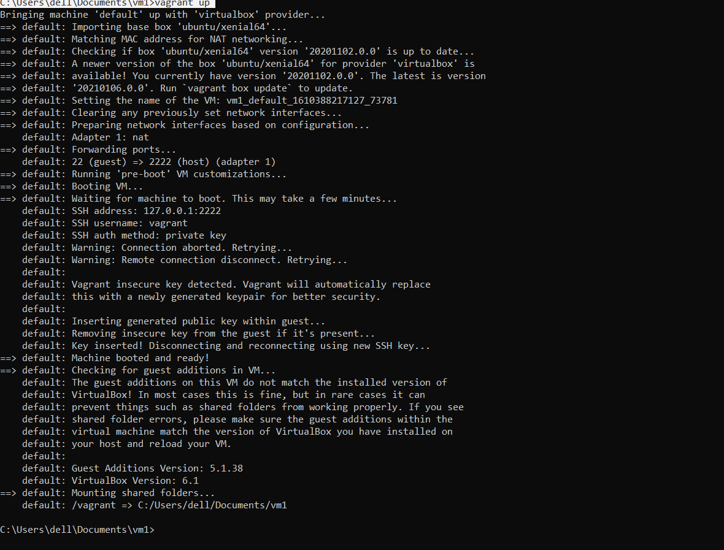

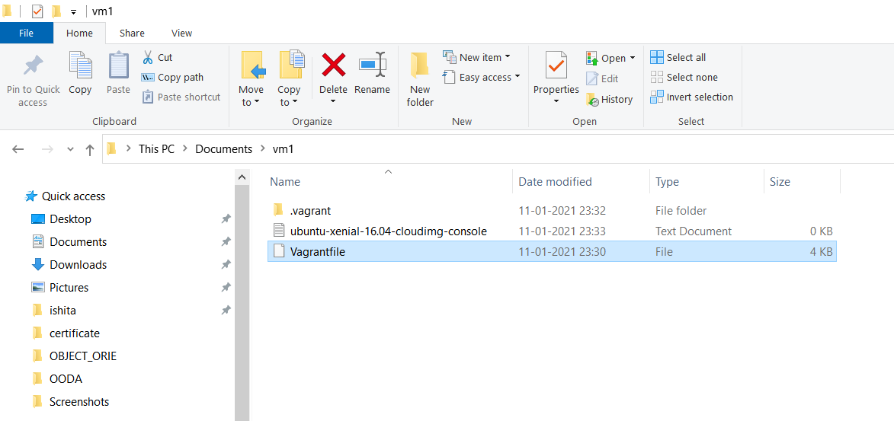

**5.] use *“vagrant ssh”* command to enter in the machine**

